Institute of Computer Technology

B. Tech Computer Science and Engineering

Subject: ESFP-II (2CSE203)

**EXTRA – PRACTICAL**

**AIM: - To learn about variables data types in C++.**

**1. Write a C++ program to print the following lines:**

**Everybody in this country should learn to program a computer....**

**Because it teaches you how to think...**

***CODE:***

#include <iostream>

using namespace std;

int main(){

cout<<"Everybody in this country should learn to program a computer....";

cout<<"\n\nBecause it teachers you how to think...";

return 0;

}

***OUTPUT:***

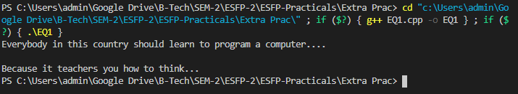

**--------------------------------------------------------------------------------------------------------**

**2. Take user as input her/his name and print this name on the screen, as**

**shown below. The text from keyboard can be read by using cin>> and to display**

**the text on the screen you can use cout<<.**

**i.e. Hello C++!**

***CODE:***

#include <iostream>

using namespace std;

int main() {

char name[30];

cout<<"Enter your name: ";

cin>>name;

cout<<"Your name is: "<<name;

return 0;

}

***OUTPUT:***

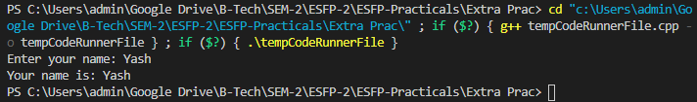

**--------------------------------------------------------------------------------------------------------**

**3. To prompt the user to input 3 integer values and print these values in**

**forward and reversed order, as shown below.**

**Please enter your 3 numbers: 10 20 30**

**Your numbers forward:**

**10**

**20**

**30**

**Your numbers reversed:**

**30**

**20**

**10**

***CODE:***

#include <iostream>

using namespace std;

int main() {

int arr[3],i,j,temp;

cout<<"\nEnter any three numbers: ";

for (i = 0; i < 3; i++)

{

cin>>arr[i];

}

cout<<"\nYour numbers forward:\n";

for (i = 0; i < 3; i++) {

cout<<arr[i]<<endl;

}

cout<<"\nYour numbers reversed:\n";

for (i = 2; i >= 0; --i) {

cout<<arr[i]<<endl;

}

return 0;

}

***OUTPUT:***

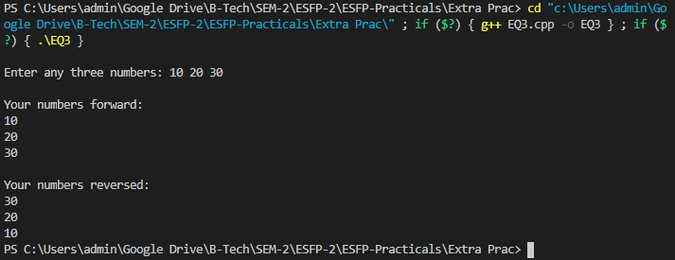

**--------------------------------------------------------------------------------------------------------**

**Post Practical Quiz - Multiple Choice Questions:**

**1. What is the additional feature in classes that was not in structures?**

a) Data members

***b) Member functions***

c) Static data allowed

d) Public access specifier

**2. Which is most appropriate comment on following class definition:**

**class Student**

**{**

**int a;**

**public: float a;**

**};**

***a) Error: same variable name can’t be used twice***

b) Error: Public must come first

c) Error: data types are different for same variable

d) It is correct

**3. If a function can perform more than 1 type of tasks, where the function name remains same, which feature of OOP is used here?**

a) Encapsulation

b) Inheritance

***c) Polymorphism***

d) Abstraction

**4. Which feature can be implemented using encapsulation?**

a) Inheritance

***b) Abstraction***

c) Polymorphism

d) Overloading

**5. Which is private member functions access scope?**

***a) Member functions which can only be used within the class***

b) Member functions which can used outside the class

c) Member functions which are accessible in derived class

d) Member functions which can’t be accessed inside the class